Introduction
Purpose and scope of this document
This document is the project management plan for the CS4433 individual project. It also contains the first stakeholder analysis for the requirements phase. Sections 3 to 7 cover the Phase 1 deliverables: the feasibility study, the work breakdown and schedule, and the risk register. Sections 8 to 10 cover the start of Phase 2, which is the stakeholder analysis and conflict resolution. The document will be updated at each gate: Gate 1 (requirements), Gate 2 (design) and Gate 3 (verification and validation).
The system in brief
A secondary school needs a Learning Management System (LMS) to manage courses, assignments and marking. There are four types of user: students, lecturers, Heads of Department (HoDs) and a system administrator. Each submission goes through set stages (submitted, late, marked, moderated and released). Every change to a mark must be recorded so the school can see who changed it, when, and why. The system is a C++17 program that uses SQLite for storage and runs offline on one school computer or a local network.
The following are out of scope: online payments, video conferencing, automatic grading, plagiarism detection, and web or mobile versions.
Development process
The project uses the Waterfall model with V-model testing, as the brief requires. Each phase finishes with a written deliverable, and coding cannot start until the design has passed Gate 2. Each level of testing is matched to the document it checks, which are:
- Unit tests check the detailed design.
- Integration tests check the architecture.
- System tests check the software requirements specification (SRS) and the use cases.
- Acceptance tests check the stakeholders' needs.
Waterfall is usually not a good choice for a small system where the requirements might change (Sommerville, 2016, section 2.1). It still works here for a few reasons, being the brief already fixes the scope, there is only one developer, the design gates give formal points to review the work, and the Phase 8 change request shows how change is handled after release. The biggest problem with Waterfall is that feedback comes late. To reduce this, I will confirm my assumptions at Gate 1 and write test cases from the requirements as I write them.
Organisation of the project
Role | Who | Responsibility
Developer | Kopo Nkone | Planning, requirements, design, implementation, testing, configuration management and documentation.
Supervisor | Dr. M.P. Morolong | Formative review at Gates 1, 2 and 3; feedback on assumptions and decisions.
Stakeholder sources | Principal, lecturer, HoD, student representative, IT officer | Source of requirements, taken from the interview statements in the brief.

PHASE 1
Feasibility Study
Feasibility studies | Question(s) that need to be asked | Evidence to gather from the lms | should we go ahead?
Economical | Do we have the budget for it? | Git, CMake, SQLite are free | Yes
Legal | Are there any laws that restrict our project? | Learners' personal data (many are minors) and assessment records; national data-protection law; third-party library licences; ownership of student work. | Feasible with safeguards mentioned
Technical | Can we build our software with the available tools and/or software? | There are 800 students, the system needs to be offline(internet is unreliable), the available computers are old school,( Git, CMake, SQLite, GoogleTest available) | Yes
Schedule | Can we finish this project on time? | 7 weeks, implementation is 4-5 weeks | Tight
Operational | Will people actually use this? | Training is necessary as “teachers are not IT experts” | If the interface is easy enough, yes

Recommendation: Go conditionally
Work Breakdown Structure (WBS)

Gantt chart
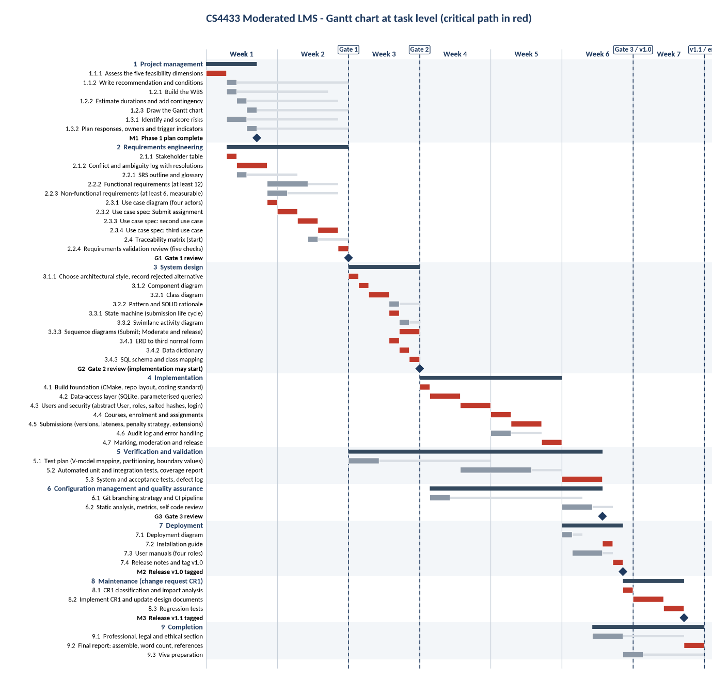
Milestones

Milestone | Project day | Date
Gate 1 - requirements reviewed | 14 | 11/10/2026
Gate 2 - design reviewed (implementation may start) | 21 | 18/10/2026
Gate 3 - verification and validation reviewed | 42 | 08/11/2026
Release v1.0 tagged | 42 | 08/11/2026
Release v1.1 tagged | 49 | 15/11/2026
Viva | 49 | 15/11/2026

Critical Path
The critical path is the longest chain of dependent tasks; any delay on it delays the whole project (Sommerville, 2016, ch. 23). Here it runs stakeholder analysis, then the SRS and use case model, then the design (Gate 2), then implementation, then system and acceptance testing, then packaging (v1.0), then the change request (v1.1). Tasks with slack are drafting the test plan, setting up the CI pipeline and static analysis, and writing the report.

Risk Management

Score | Likelihood | Impact (on the project)
1 | Rare | Negligible: no effect on schedule or marks
2 | Unlikely | Minor: under a day lost
3 | Possible | Moderate: one to three days lost or one deliverable weakened
4 | Likely | Serious: a gate is missed or a must requirement is at risk
5 | Almost certain | Catastrophic: the project fails or marks are lost across phases

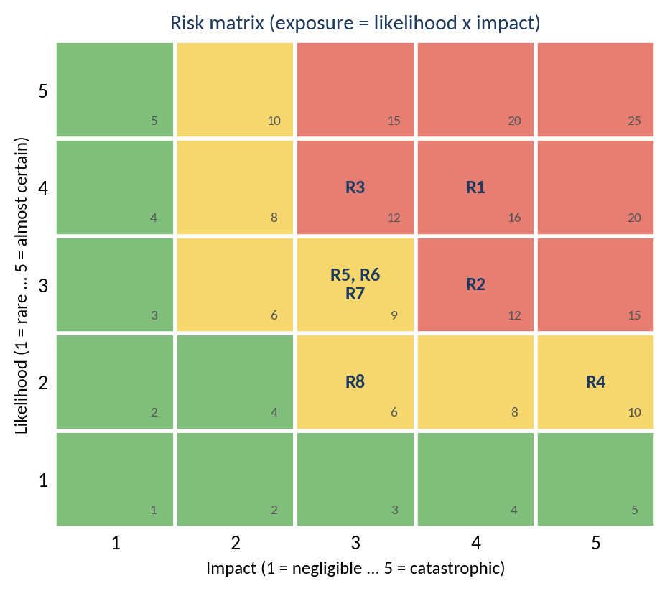

Risk register (version 0.1)
ID | Type | Risk (cause, event, consequence) | L | I | Exp. | Response (mitigation / contingency) | Trigger indicator | Owner | Gate 1 status
R1 | Technical (estimation) | The implementation window is two weeks for the largest mark block. Effort for C++, SQLite and security is underestimated, so “must” requirements are unfinished. | 4 | 4 | 16 | Minimise: MoSCoW scope; simple design; trial build of the toolchain before Gate 2. Contingency: let go of “Could” items, then “Should” items. | Implementation tasks run over 20% of their window | Developer | Open
R2 | Project (requirements) | Conflicts are resolved wrongly, or assumptions stay unconfirmed, so the SRS and design need rework after Gate 1. | 3 | 4 | 12 | Avoid: log every assumption with its source; confirm at the Gate 1 review. | A new conflict is found after Gate 1 | Developer / supervisor | Open
R3 | People | Other coursework, exams or illness reduce the hours available. | 4 | 3 | 12 | Minimise: fixed weekly hours; contingency in the estimate; finish early deliverables early. | Logged hours below plan two weeks running | Developer | Open
R4 | Tools | Source code or documents are lost through device failure or no backup. | 2 | 5 | 10 | Avoid: push to the hosted repository daily. Contingency: restore from the remote. | No push for 24 hours | Developer | Open
R5 | Technical | The password-hashing library does not build or link with CMake on the development machine or in CI. | 3 | 3 | 9 | Avoid: trial build early; choose a library with CMake support; name a fallback library. | Trial build fails | Developer | Open
R6 | Project | Scope creep (GUI polish, out-of-scope features such as payments or web access). | 3 | 3 | 9 | Avoid: explicit out-of-scope list and MoSCoW Won't items in the SRS. | Plan tasks that trace to no Must requirement | Developer | Open
R7 | Technical | SQLite locking or corruption if several users share one database file over a network. | 3 | 3 | 9 | Avoid: single-machine deployment for v1.0. Minimise: transactions and a busy timeout. | Database-locked errors in tests | Developer | Open
R8 | Project | Gate feedback arrives late or forces rework of the design. | 2 | 3 | 6 | Minimise: book gate reviews in advance; send documents ahead of each gate. | No review booked three days before a gate | Developer / supervisor | Open

